About a code conflict between Electron and ArcGIS JS API 4.x.

1. Please download the Electron-vue-arcgis.zip and unzip it，run yarn(npm) install

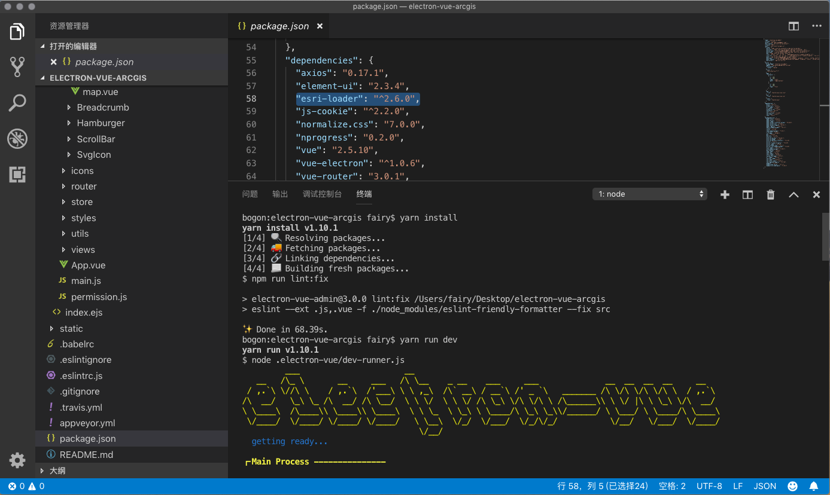

The esri-loader version is 2.6.0.

Run yarn run dev，error occurred.

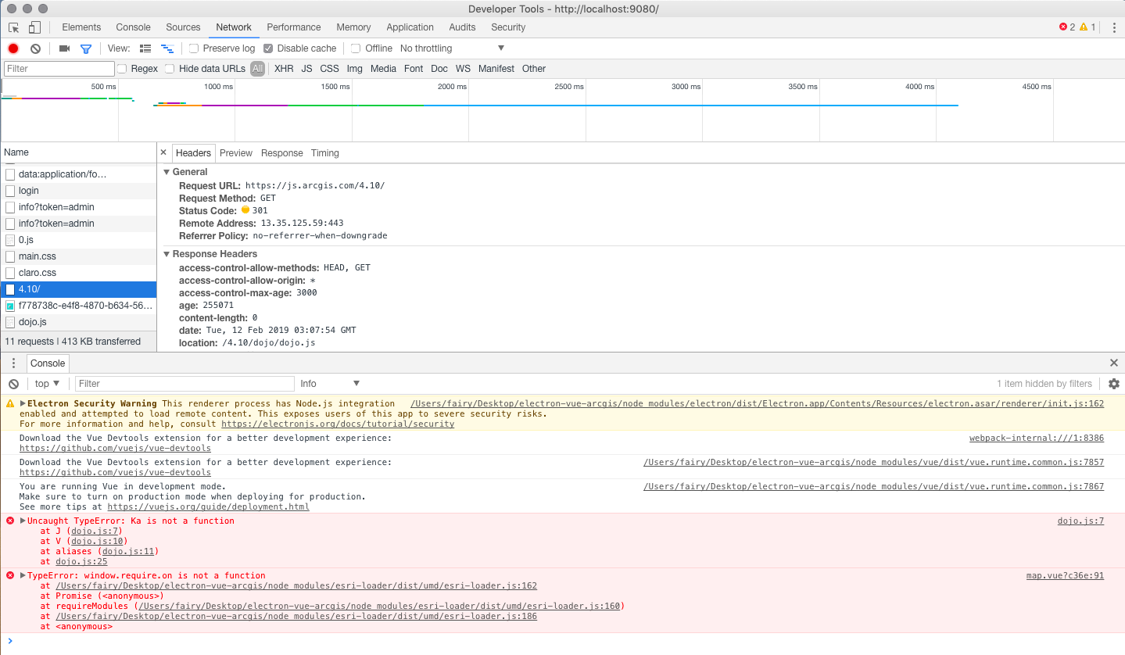

The arcgis js api version is 4.10

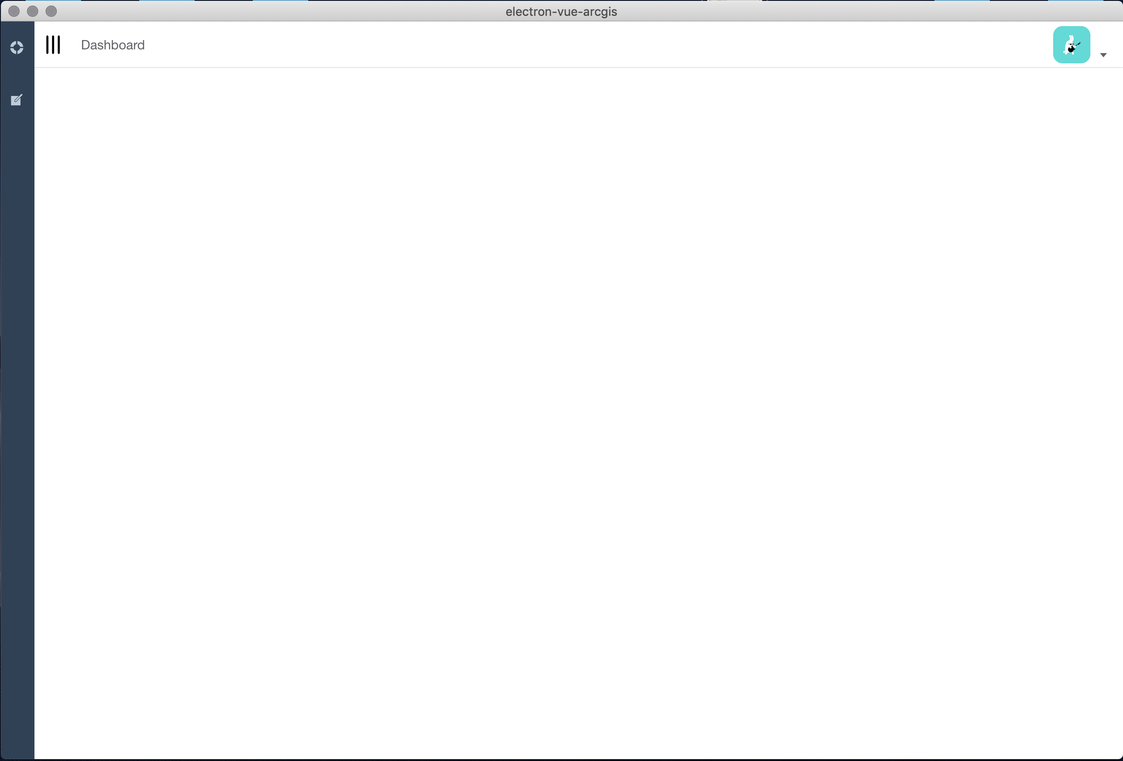

The map cannot show.

1. Please remove the node_modules folder，open package.json, change esri-loader to 2.2.0（remove ^ at the same time），run yarn install、yarn run dev

This step is designed to switch the called version of ArcGIS JS API.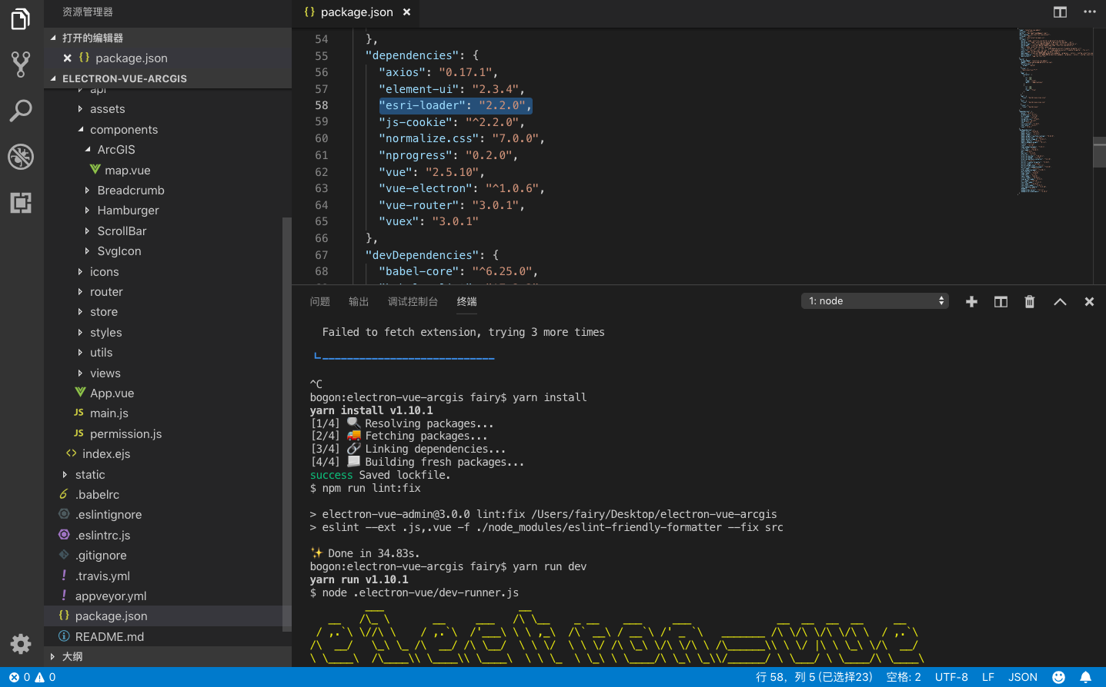

And there is no problem.

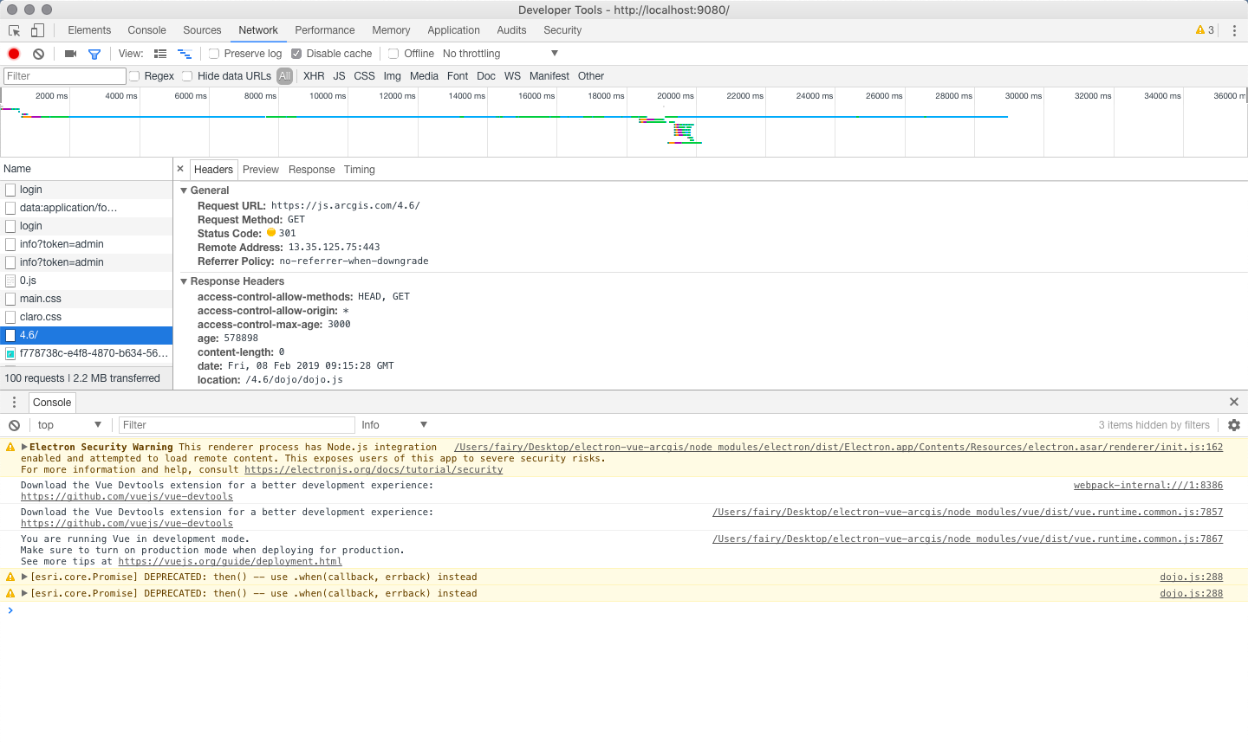

esri-loader called arcgis js api 4.6

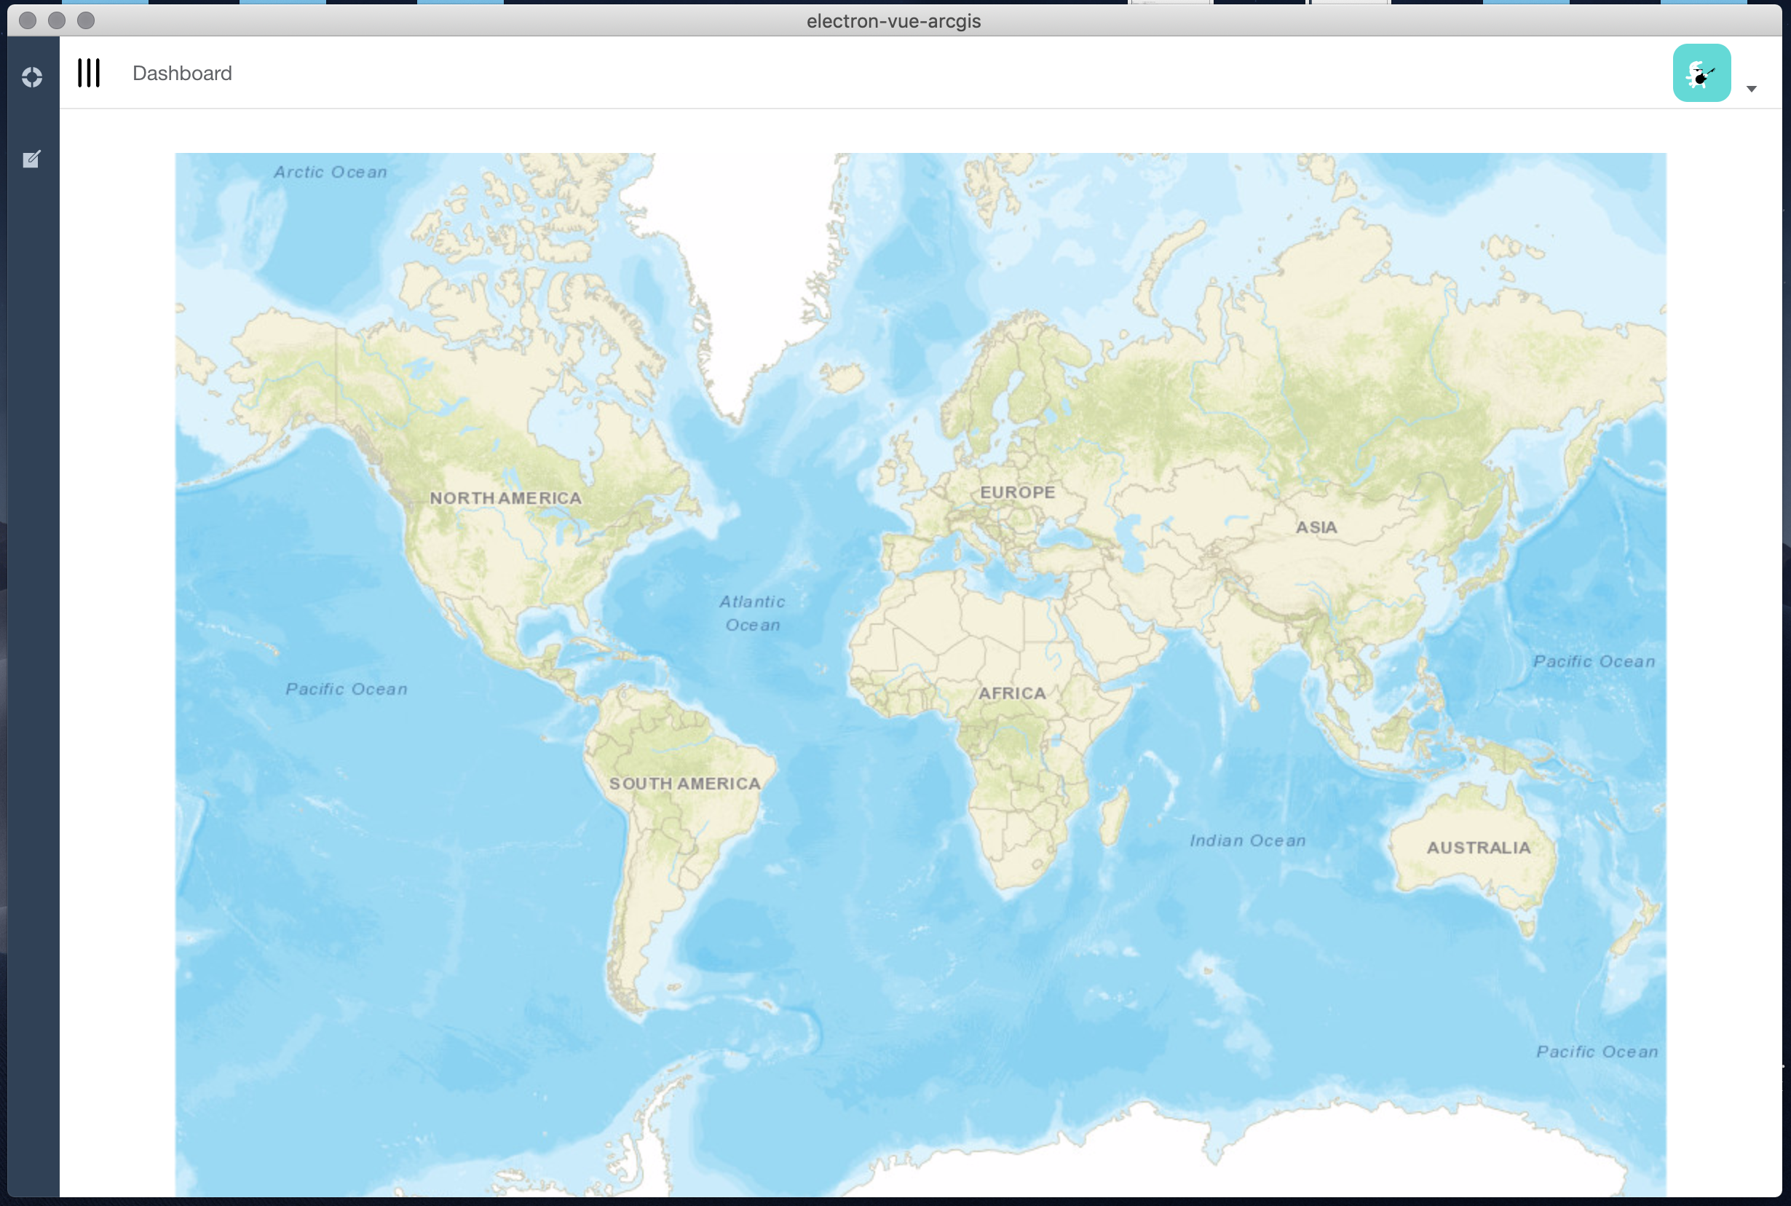

We can see the map.

1. In addition to the above two versions, we have tested all adjacent arcgis js api versions，4.6 & 4.7 don’t have problem, starting from 4.8, 4.8, 4.9 and the latest 4.10 will report an error.